

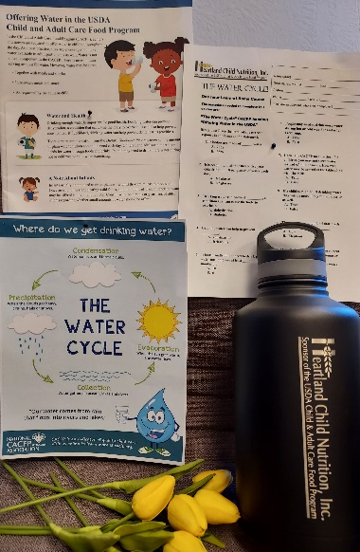

**USDA Issues New Waivers**

**The USDA has announced a new set of waivers to ensure children across the nation have access to nutritious meals as we recover from the pandemic. Starting July 1, 2022 through June 2023 all family child care providers on the food program are eligible to be Tier 1, regardless of location or income. Please call Dorleen at 701-250-0140 with any questions. The updated Tier 1 rates are:**

**Breakfast: $1.66**

**Lunch/Supper: $3.04**

**Snack:  $0.97**

**Trimester packages will be delivered soon! They include a Water Learn-at-Home course as well as a nice water container for your daycare.** 



Peach and Yogurt Smoothies - USDA Recipe for Child Care Centers

* 3 ½ lbs. of peaches (frozen, unsweetened, thawed, drained
* 24 oz. Vanilla yogurt, low-fat.

Instructions:

Combine peaches and yogurt in a blender. Mix until smooth.

Serve ¾ cup (6 oz. ladle). Serve immediately, or keep cold at 40 degrees or lower.

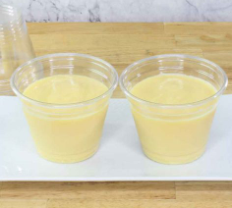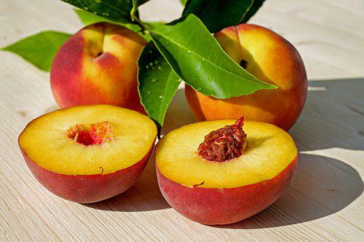

**CACFP CREDITING INFORMATION**

½ cup fruit

½ oz. eq. meat alternate

**We understand the difficulty with the formula shortage. Please note: Only medical professionals are qualified to provide advice on acceptable alternatives to formulas that may currently be difficult to find. The American Academy of Pediatrics offers tips for parents and caregivers who are struggling to find baby formula during the shortage. Please talk with your pediatrician about safe and appropriate feeding alternatives for your child if needed.**

P.O. Box 1218, 521 Main St. Suite 420

Bismarck, ND 58502-1218

701-250-0140 or 800-366-6793

[hcn@hearlandnutrition.org](mailto:hcn@hearlandnutrition.org) www.heartlandnutrition.org



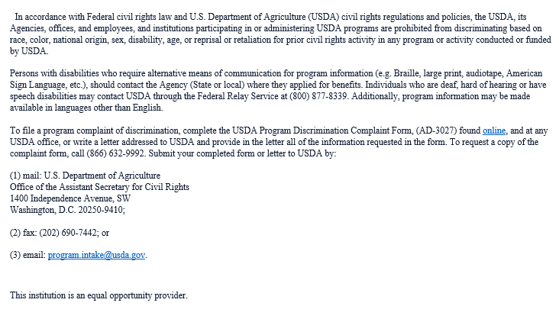

**School will be starting again soon. Remember to mark schools out after Labor day to avoid deductions!**



**Economical Snack Ideas**

**Celery and Peanut Butter**

**Tortilla wrap with refried beans**

**Cheese and Crackers**

**Popcorn and hummus**

**Carrots and Roasted Chickpeas**

**Apples and Toast**

IMPORTANT! **The 2022 Mandatory CACFP Provider Training is due. If you have not already completed your training get it in ASAP. The quiz is an annual requirement for food program participants as documentation to USDA that participating child care providers are knowledgeable of basic CACFP regulations and policies.**

**Parmesan Zucchini Chips**

**Prep time: 20 min. Cook Time: 20 min.**

**CACFP Crediting: ½ c. veg. ¼ oz. grains**

* **5 c sliced zucchini**
* **¼ c mayonnaise**
* **Nonstick Cooking Spray**
* **½ c. whole-wheat breadcrumbs**
* **1 ½ Tb parmesan cheese**

**Preheat oven to 400 degrees F.**

**Line baking sheet with foil then spray with cooking spray. Combine breadcrumbs, Italian seasoning and parmesan. Stir. In a separate bowl, combine zucchini rounds and mayonnaise then stir until all rounds are coated. Next add the breadcrumb mixture and stir until all rounds are coated. Place zucchini rounds in a single layer on prepared baking sheet. Sprinkle remaining breadcrumbs on top. Bake for 20 minutes or until crispy.**

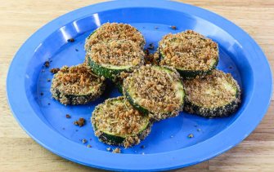

**We want you to receive the most money possible each month.**

* **Reminder: Child Enrollment Forms must be renewed annually for each child in care to reflect any changes in a child’s hours or meals served and/or when there is a change of address or phone of parent/guardian. Enrollment renewals are a USDA requirement for all participants.**