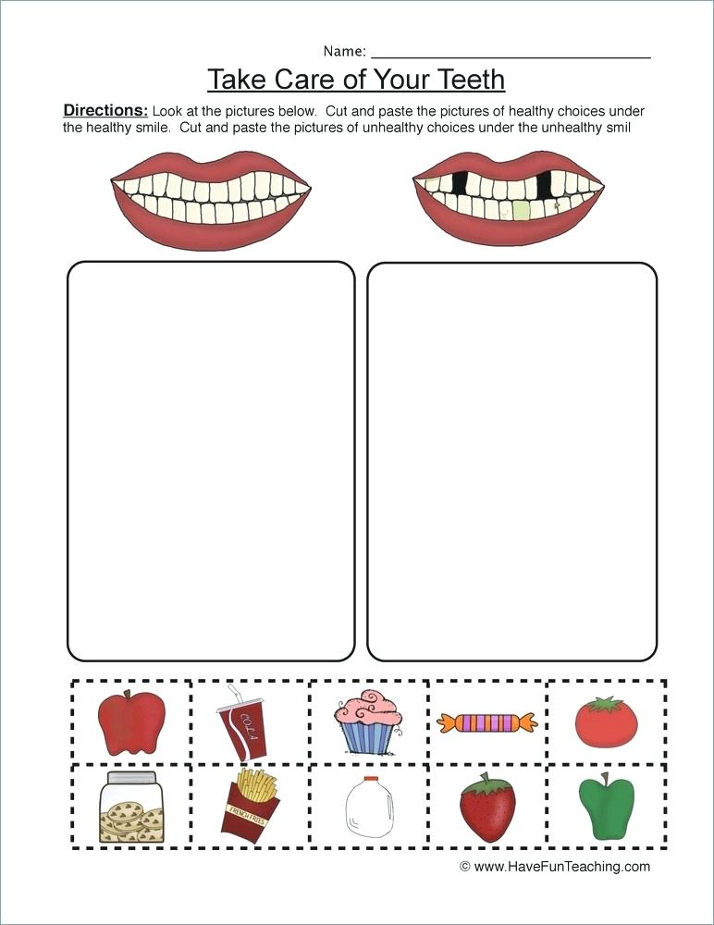

Name _____________________



www.heartlandnutrition.org

Directions: Have a discussion with the children about what foods are good for strong teeth because they have calcium in them. There are also foods that help clean our teeth because they are crispy and nutritious. Talk about what foods are not so good because they have lots of sugar in them that may stick to our teeth. The sugar can cause teeth to have a cavity if not brushed off.

Cut the bottom food squares out for each child or, if developmentally ready, the child may cut out. Instruct the children to place a smear of glue in a dotted box. Then help them choose a correct food for to place in the box. Continue with the other squares.

FOODS THAT ARE GOOD FOR OUR TEETH

