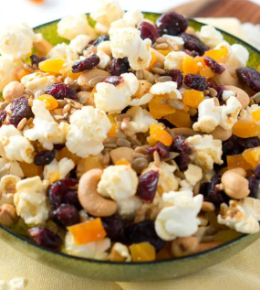
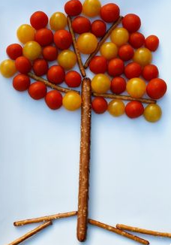
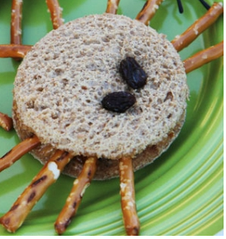
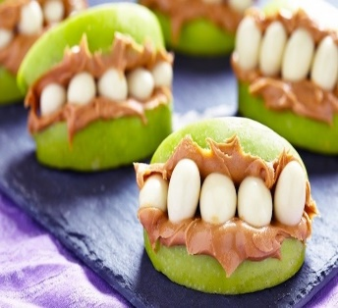
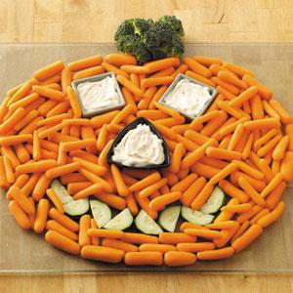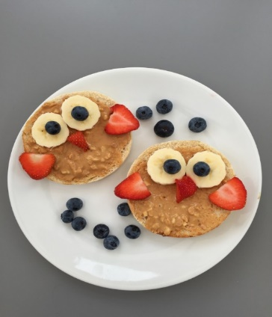
Healthy Snacking ideas inspired by Pinterest!
- Carrot, cucumbers, and broccoli pumpkin face.
- Make an owl using bread, peanut butter, bananas, blueberries and strawberries.
- A unique pretzel and tomato combination to create your own tree.
- Apples and peanut butter. Yum!
- Peanut butter sandwich with pretzels for legs, and raisin eyes.
- Create your own popcorn snack mix with dried fruit and nuts.

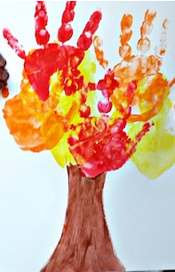
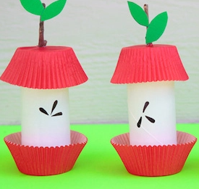
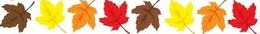
Zucchini Bread
- 1 ½ cups sugar - 1 tsp. baking soda
- 3 eggs - ½ tsp. baking powder
- ½ cup oil - 1 tsp. salt
- ½ cup applesauce - 1 tsp. ground cinnamon
- 1 teaspoon vanilla extract - ¾ tsp. allspice
- 3 cups flour - 2 cups grated zucchini
Instructions:
Preheat oven to 350 degrees, and spray 4 mini loaf pans with nonstick spray. Whisk together sugar, eggs, oil and applesauce until creamy then add vanilla extract. In a separate bowl, mix flour, baking soda, baking powder, salt, cinnamon and allspice. Add the flour mixture to the wet ingredients and mix together. Fold in grated zucchini. Pour the batter evenly into each loaf pan. Bake for 35-40 minutes, or until a toothpick inserted into the center of the loaf comes out clean.
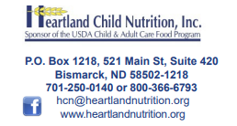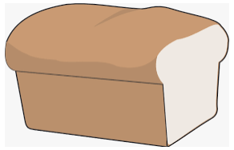
Craft ideas from Pinterest:
Above is a neat craft using household supplies that can help to educate children on the parts of an apple.
Below is a cute tree created by using hand paint that kids will love to make!
September 2021
Heartland Child Nutrition
HORIZONS
A Newsletter for ND Child Care Providers Participating
In the Heartland Child Nutrition USDA Food Program
WGR


Welcome Back to School!
Remember to mark when school is out to avoid deductions on your claim.
Also be sure to check if you recorded your whole grain rich item on your menu’s once per day to avoid deductions.

Heartland is pleased to offer our providers the 2022 CACFP Calendar with a one-hour learn-at-home course. To be delivered at home visits in October-January.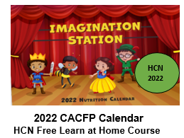

Beginning Oct. 1 the Grain Component Crediting will be changing from “Serving” to “Ounce Equivalents”
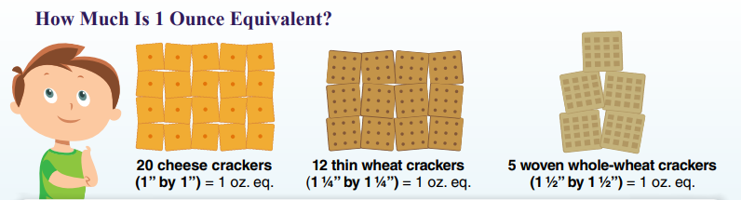
To ensure participants are getting enough grains USDA is changing the way grain foods are measured in reimbursable meals. It is likely that the portion size of grain items that you serve will not change. This is simply a wording change on how grains are measured. The USDA has created a grain measuring chart along with many helpful tools to assist providers with the change to ounce equivalents. The staff at Heartland Child Nutrition will also be creating a course to help you better understand this information.
Ounce equivalents measure the amount of grain in a food item instead of measuring the total weight of all ingredients. One ounce equivalent of grains is the amount you need to make up 16 grams of grains. In a creditable serving for a 1-5-year-old, ½ oz. of grain is required for a reimbursable meal. The USDA grain measuring chart shows that 1/2 slice of a whole grain rich or enriched piece of bread contains 14 grams of grain.
Previously the USDA measured all cereals the same regardless of weight. Some cereals like Rice Krispies are puffed with air compared to a denser cereal like Cheerios. Because of the way these cereals are made a one-ounce portion of cheerios is equivalent to 1 cup and a one-ounce portion of Rice Krispies is equivalent to 1 ¼ cup. The web address to the ounce equivalent grain measuring chart is provided below.
https://www.fns.usda.gov/tn/using-ounce-equivalents-grains-cacfp

